Benefice Noticeboard July 2022

St Peters Church Nature Detectives Summer Club
A huge thankyou to the team of Ginny, Toni, Anne, Andrea, Tracey and Wendy for all their help and enthusiasm. The children enjoyed a fun packed week learning about God’s creation through activities, games, crafts, snacks, worship and singing and went away with a decorated box full of the things they had made, a certificate of attendance and some goodies

Online service of Holy Communion please go to YouTube 4spiresbenefice

Stanwick Fete – Saturday 10th September – watch this space for more info

Hargrave Music Festival 2022– 16th to 18th September – all concerts and performances are held in the church and admittance is by ticket only for further information please contact Pat Worden on 01933 623524

Sunday 31st July
Benefice Service St Peters Church Raunds

Gospel Reading Luke 12: 13 - 21

Parable of the Rich Fool
¹³ Then someone called from the crowd, “Teacher, please tell my brother to divide our father’s estate with me.”
¹⁴ Jesus replied, “Friend, who made me a judge over you to decide such things as that?” ¹⁵ Then he said, “Beware! Guard against every kind of greed. Life is not measured by how much you own.”
¹⁶ Then he told them a story: “A rich man had a fertile farm that produced fine crops. ¹⁷ He said to himself, ‘What should I do? I don’t have room for all my crops.’ ¹⁸ Then he said, ‘I know! I’ll tear down my barns and build bigger ones. Then I’ll have room enough to store all my wheat and other goods. ¹⁹ And I’ll sit back and say to myself, “My friend, you have enough stored away for years to come. Now take it easy! Eat, drink, and be merry!”’
²⁰ “But God said to him, ‘You fool! You will die this very night. Then who will get everything you worked for?’
²¹ “Yes, a person is a fool to store up earthly wealth but not have a rich relationship with God

Readings for Sunday 7th August
Isaiah 1: 1, 10 to 20
Psalm 50: 1 to 8
Hebrews 11: 1 to3. 8 to 16
Luke 12: 32 to 40

A Prayer for Ukraine
God of peace and justice,
we pray for the people of Ukraine today.
We pray for peace and the laying down of weapons.
We pray for all those who fear for tomorrow,
that your Spirit of comfort would draw near to them.
We pray for those with power over war or peace,
for wisdom, discernment and compassion to guide their decisions.
Above all, we pray for all your precious children, at risk and in fear,
that you would hold and protect them.
We pray in the name of Jesus, the Prince of Peace.
Amen Archbishop Justin Welby & Archbishop Stephen Cottrell

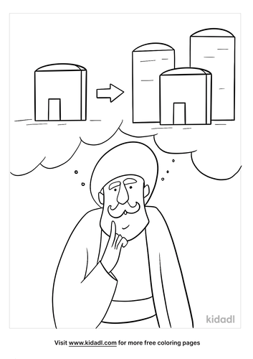

Jesus says, “A person is a fool to store up earthly wealth but not have a rich relationship with God”

St Peter, Raunds

Churchwardens
Mike Turner Tel. 623289, Andrea Haseldine Tel. 624644

Today: 10.00am Benefice service
This week
Monday
Tuesday
Wednesday
Thursday
Friday
Saturday
Next Sunday 3pm All Age Communion

All Hallows, Hargrave
Churchwardens
Savitri Pollard Tel. 626960, Helen Parry Tel. 622959

Today: 10.00am Benefice service St Peters
This Week
Monday
Tuesday
Wednesday
Thursday
Friday
Saturday
Next Sunday 10.00am Holy Communion

Nativity of blessed virgin Mary, Ringstead
Churchwardens
Cliff Harris Tel. 625126, Rosemarie Coles Tel. 624262

Today: 10.00am Benefice service St Peters
This week
Monday
Tuesday
Wednesday
Thursday
Friday
Saturday
Next Sunday 10.00am Worship

St Laurence, Stanwick

Churchwardens
Lisa Adair Tel. 778967, Sam Chambers Tel. 623855

Today: 10.00am Benefice service St Peters

This Week
Monday 7.00pm PCC
Tuesday 4.00pm to 5.30pm Bell ringing practice
Wednesday
Thursday
Friday Stanwick Youth group
Summer break during August see you in September
Saturday
Next Sunday 9.30am Café Church

