Benefice Noticeboard April 2022

Lent Bible study – exploring the four Gospels. It is not too late to join please contact Rev. Jon for the link on revjonaldwinckle@btconnect.com

Lent Lunch on Thursday in St Laurence, Stanwick at 12 noon, please support, a donation is suggested of £3.50 with all proceeds going to charity

Quiet Day, Little Gidding - deadline to sign up for quiet day is Tuesday 5th April. The cost for this day of reflection and worship is £20 per person which includes refreshments on arrival, a light lunch and tea & cake before departure. Please email Rev Jon to reserve a place on revjonaldwinckle@btconnect.com

Online service of Holy Communion please go to YouTube 4spiresbenefice

St Peters Church Spring Lunch – Sunday April 24th at 12noon in church
St Peters church invites you to join us for a light lunch and fellowship together if you would like to come along then please sign your name on the list at the back of your church. For catering purposes, we need to know numbers so the cut-off date for reserving your place will be Easter Sunday 17th April

Next Wednesday Worship will be on 11th May in St Mary’s Ringstead

3rd April Fifth Sunday of Lent
Passiontide begins
Gospel reading John 12: 1-8

Jesus Anointed at Bethany
12 Six days before the Passover celebration began, Jesus arrived in Bethany, the home of Lazarus—the man he had raised from the dead. ² A dinner was prepared in Jesus’ honour. Martha served, and Lazarus was among those who ate^{[a]} with him. ³ Then Mary took a twelve-ounce jar^{[b]} of expensive perfume made from essence of nard, and she anointed Jesus’ feet with it, wiping his feet with her hair. The house was filled with the fragrance.
⁴ But Judas Iscariot, the disciple who would soon betray him, said, ⁵ “That perfume was worth a year’s wages.^{[c]} It should have been sold and the money given to the poor.” ⁶ Not that he cared for the poor—he was a thief, and since he was in charge of the disciples’ money, he often stole some for himself.
⁷ Jesus replied, “Leave her alone. She did this in preparation for my burial. ⁸ You will always have the poor among you, but you will not always have me.”

Readings Sunday 10th April - Palm Sunday
Psalm 118 1 to 2, 19 to end
Luke 19: 28 to 40

A Prayer for Ukraine
God of peace and justice,
we pray for the people of Ukraine today.
We pray for peace and the laying down of weapons.
We pray for all those who fear for tomorrow,
that your Spirit of comfort would draw near to them.
We pray for those with power over war or peace,
for wisdom, discernment and compassion to guide their decisions.
Above all, we pray for all your precious children, at risk and in fear,
that you would hold and protect them.
We pray in the name of Jesus, the Prince of Peace.
Amen Archbishop Justin Welby & Archbishop Stephen Cottrell

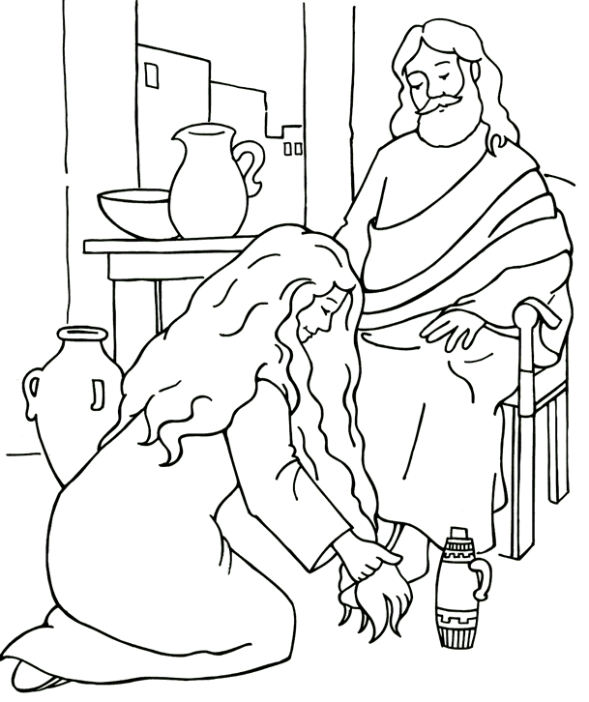

Mary anoints Jesus’s feet

St Peter, Raunds

Churchwardens
Mike Turner Tel. 623289, Andrea Haseldine Tel. 624644

Today: 3.00pm - Civic Service
6.00pm - Evensong
This week
Monday 7.00pm Bible Study
Tuesday
Wednesday
Thursday 11.00am Funeral
Friday
Saturday 1.00pm Baptism
Next Sunday 10.00am Morning Worship – Palm Sunday

All Hallows, Hargrave
Churchwardens
Savitri Pollard Tel. 626960, Helen Parry Tel. 622959

Today: 10.00am Holy Communion
This week
Monday
Tuesday 7.30pm Home group studying the book of Daniel
meeting at the home of Helen Parry
Wednesday
Thursday
Friday
Saturday
Next Sunday 10.00am Morning Worship – Palm Sunday

Nativity of blessed virgin Mary, Ringstead
Churchwardens
Cliff Harris Tel. 625126, Rosemary Coles Tel. 624262

Today: 10.00am Worship
This week
Monday
Tuesday
Wednesday
Thursday
Friday
Saturday
Next Sunday 3pm All Age Communion – Palm Sunday

St Laurence, Stanwick

Churchwardens
Lisa Adair Tel. 778967, Sam Chambers Tel. 623855

Today: 9.30am Priceless
This week
Monday
Tuesday 4.00pm to 5.30pm Bell ringing practice
Wednesday
Thursday Half term no Little Treasures
Lent Lunch 12 noon
Friday Stanwick Youth group
The next meeting will be after half term on 24th April
Juniors 6.45pm to 8.15pm -Youth section 8.30 to 10.00pm
Saturday
Next Sunday 10.00am Holy Communion – Palm Sunday

